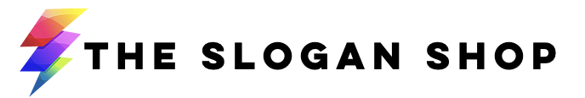
Slogan Creation Questionnaire

Note: upon completion, please send this document to us at info@thesloganshop.com. We’ll be in touch with lightning-fast speed to confirm receipt and begin work.

- Company name/website url (if available):

- Briefly describe what your company does:

- Who are your main competitors? Please list website url’s for reference if possible.

- What separates you from your competitors? What makes you unique (or what will make you unique when you launch)?

- Who is your target customer (or projected target if you’re just launching now)? Please describe them not only in demographic terms but also in terms of what motivates them, what keeps them up at night, why they need a product or service like yours, etc.

- Quick creative exercise: if your brand (or future brand) were a celebrity, who would it be and why?

- In terms of branding/messaging, what do you like or dislike about your competitors?

- Are there any famous brands (any category) you really respect and would like to emulate in the creation of your own slogan/tagline? If so, please list the relevant slogan/tagline and explain what you like about it.

- If you only had one key sentence to summarize what your company, product or service does and what sets it apart, what would you say? Note: don’t worry about making it sound nice, poetic or pretty- just straightforward language is fine.

- Any “do’s and don’ts” in terms of the name or slogan/tagline? Eg tonality to use or avoid, certain buzzwords to focus on or avoid, keywords to focus on for the slogan etc.
I

- Any additional thoughts, suggestions you’d like to add?

